Softw

**Vaccine Registration Management System**

**Introduction**:

We created this project Vaccine Registration Management System for COVID 19 vaccine registration. At the present time, corona has spread terribly all over the world. And to get rid of it, we need to vaccine. And to give that vaccine, you can easily register through this software.

In this pandemic time of COVID 19 that project or software will be help for the people. In this corona situation, without going to hospital people can easily register for the vaccine at home through this software.

**Technology:**

For making this software we are used those technology and components:

IDEA:

* IntelliJ

For Code:

* Java.
* Java swing.

For Database:

* MySQL Database (MySQL Workbench).

**Database schema and Description:**

Our Database name is “vr”. There are two schema (tables) under the vr database. The name of a schema (table) is brn_holder_information, that schema (table) contains the information of those who have registered with nid number. The other schema (table) is nid_holder_information which contains the information of those who have registered with birth certificate (registration) number. Here, those schema (tables) are hold on some attributes like ID, Name, Phone, Birth Certificate (Reg) Nubmer or NID Number, Date of birth (DOB), Location, Nationality, Vaccine Center, Vaccination Date and Vaccine Confirmation Message.Here (Database) ID is auto increment and primary key.

We also use database as an Admin. We can update various information from the database schema like Vaccination DateandVaccine Confirmation Message.

Admin

Phone Reg_No Name Phone

Name B_Info N_Info ID Reg_No

ID DOB DOB

Center

Center brn_holder_information nid_holder_information

Location Reg_Date Vaccination Location Reg_Date Vaccination

Nationality Vac_Date Nationality Vac_Date

**Many to One relationship between brn_holder_information / nid_holder_information and Admin**

**Functionality:**

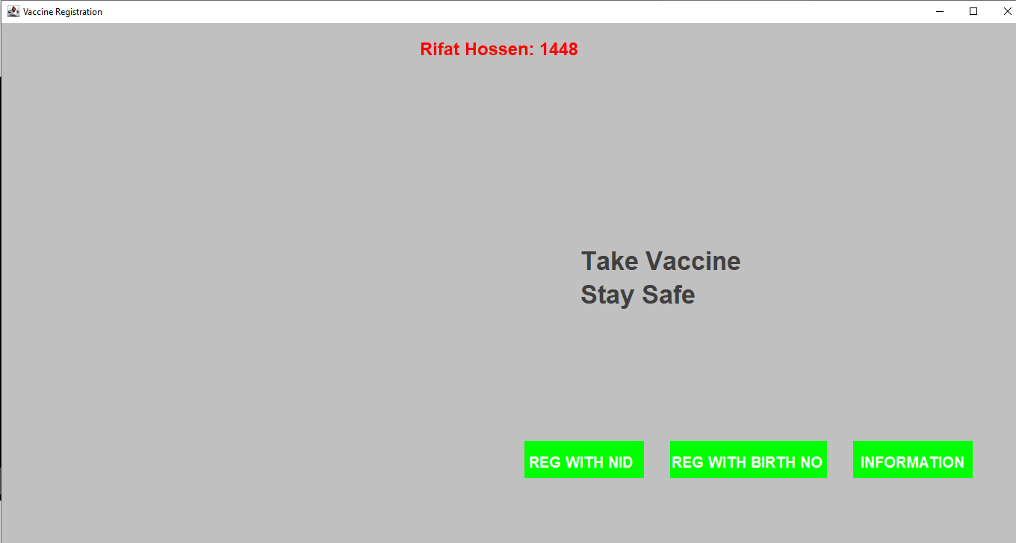

This is the first interface of our software, when we run our software this interface will be displayed. There are three options those are user can use for their registration and view their information.

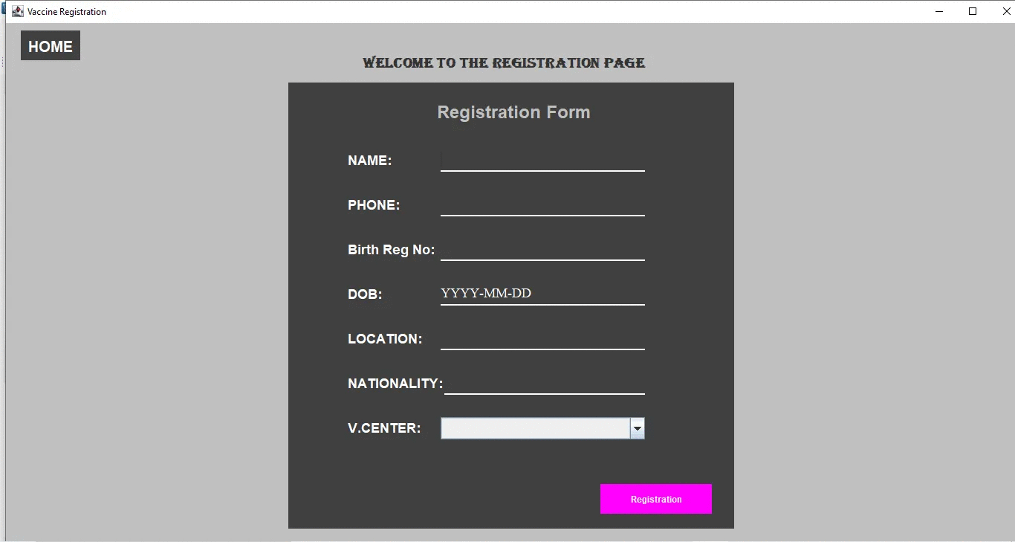 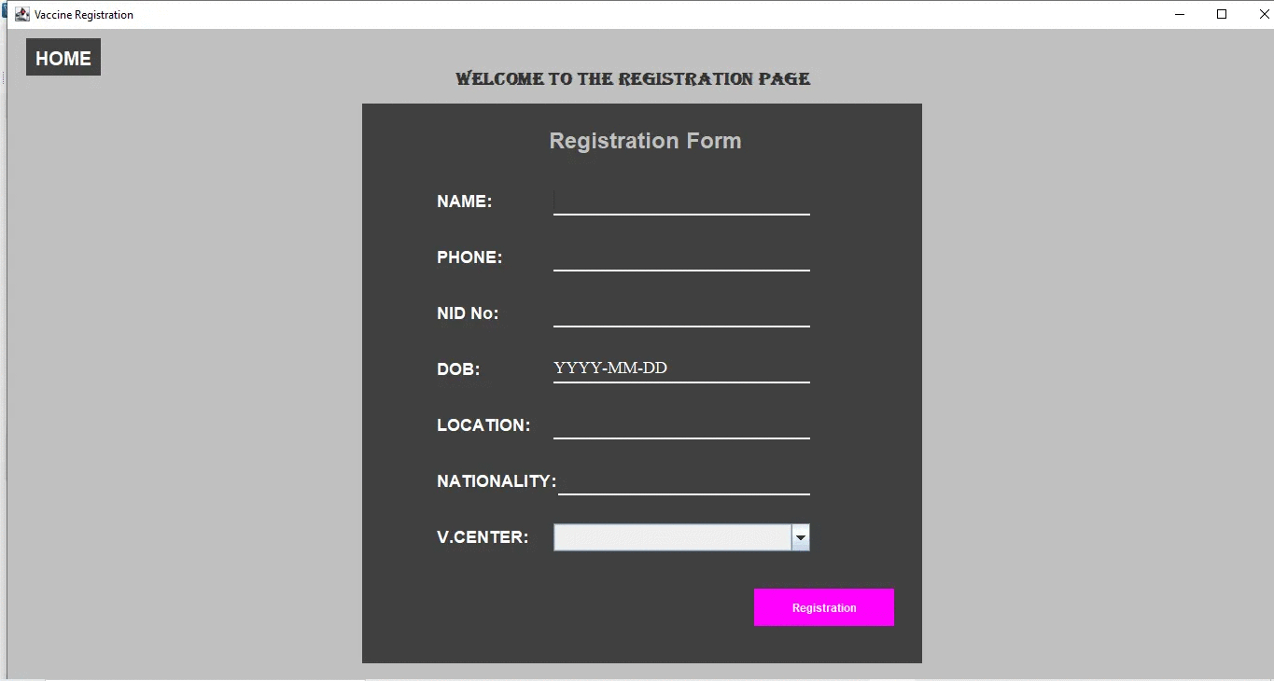

When any user click the REG WITH NID button then the first registration form will be display and when the user click the REG WITH BIRTH NO button then the second registration form will be displayed. Then successfully fill-up this form and click the Registration button for complete their registration.

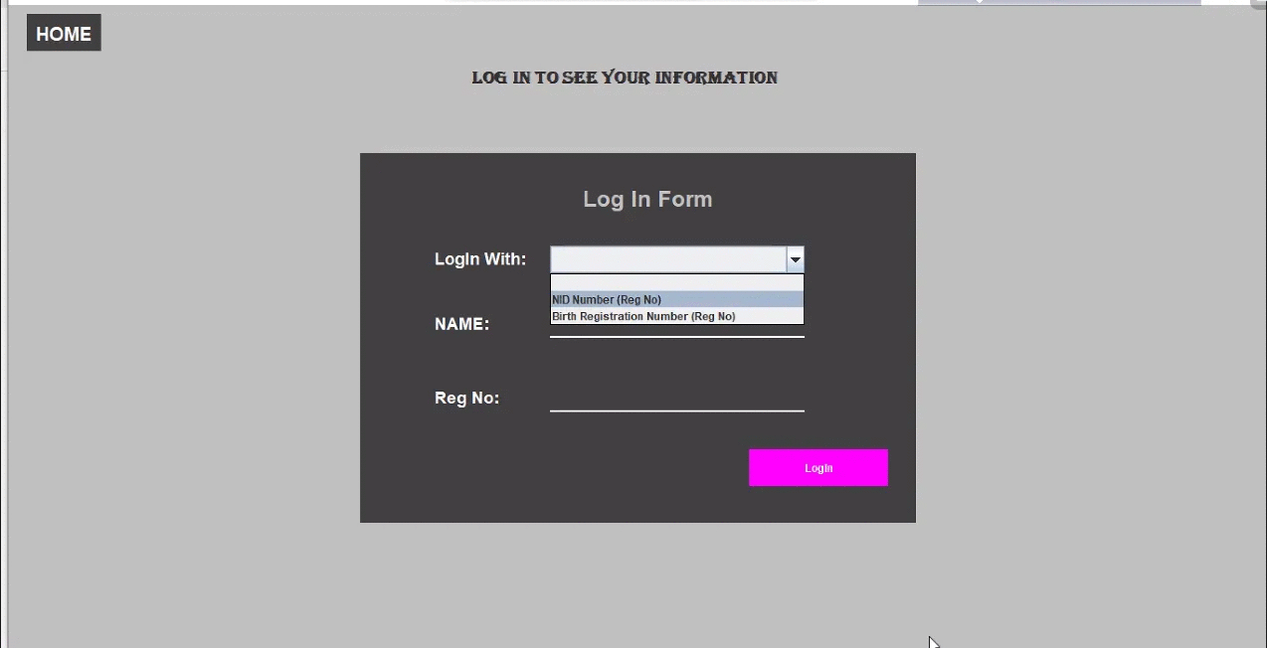 If the registered user wants to see their information, clicked the INFORMATION button and fill-up the form with correct information.

After successfully fill-up this form and click the LogIn button user can see their information. If user give wrong input(information) the app show error message.

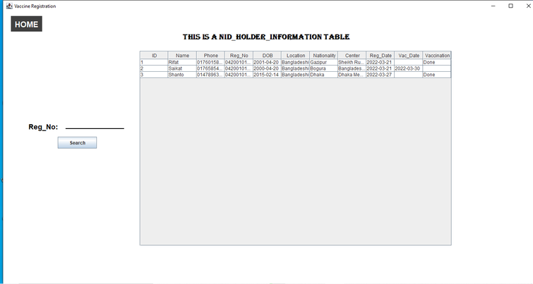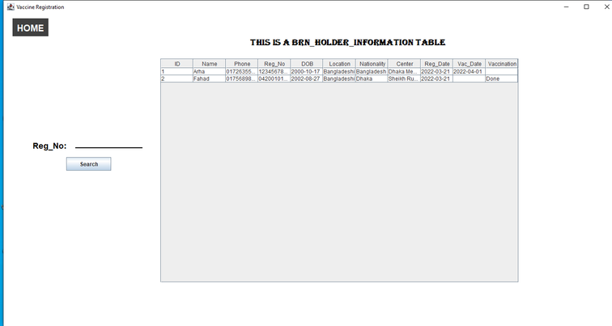   
(NID HOLDER INFORMATION TALE) (BRN HOLDER INFORMATION TALE)

User can quickly and easily find their own information by searching with their Registration Number.

**Conclusion:**

Current time the project of Vaccine Registration Management System is most important for the world. The Vaccine Registration Management System is an application that helps peoples for registration their vaccine dose and save the world from COVID 19.

**Future expansion:**

This paper proposes a Vaccine Registration Management System which we believe will bring remarkable change. We will update this software further and contact all the hospitals so that the subsequent user can use this software not only for COVID 19 vaccine registration but also for all diseases at his nearest hospital. We will work on the aspect that can register for all treatment.